**Software Engineering Lab Task 3**

**11-12-2024**

**Eshwar Deshmukh Chavan**

**HU22CSEN0100999**

Implement weather modelling using the quadratic solution in stages: hard-coding variables keyboard input, read from a file, for a single set of input, multiple sets of inputs. save all versions, debug, fix problems, create a GitHub account.

**Aim:**

To model weather temperature using a quadratic equation, demonstrating three scenarios:

1. **Hardcoded Values**: Predefined inputs for simplicity.
2. **Keyboard Input**: User-provided inputs for flexibility.
3. **File Input**: Reading inputs from a file for automated processing.

About the Program:

* The program utilizes a quadratic equation to model temperature changes over time.
* Equation given by:

Temperature=a×(time)^2+b×(time)+c

1. Hardcoding Variables:
   * Predefined values for coefficients a*a*, b*b*, and c*c*.
   * Calculate temperature for a given time using these hardcoded values.

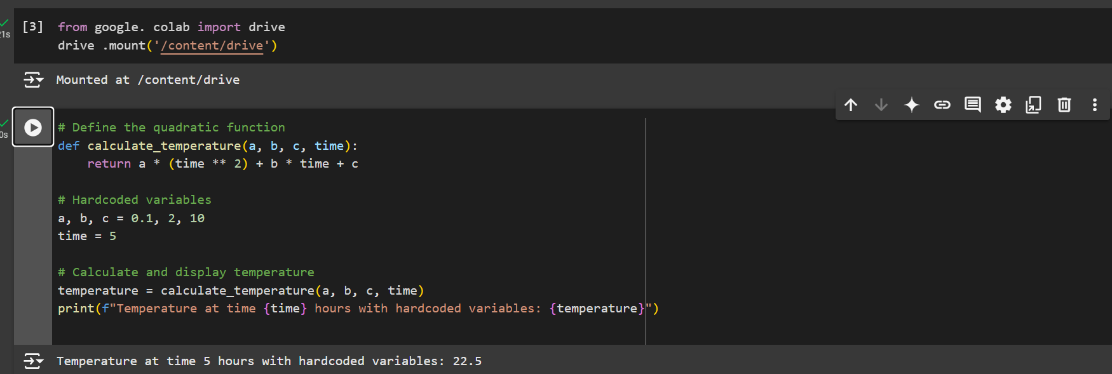

1. Accepting Variables via Keyboard Input:
   * Prompt the user to enter values for coefficients a*a*, b*b*, and c*c*.
   * Calculate temperature for a given time using these user-provided values.

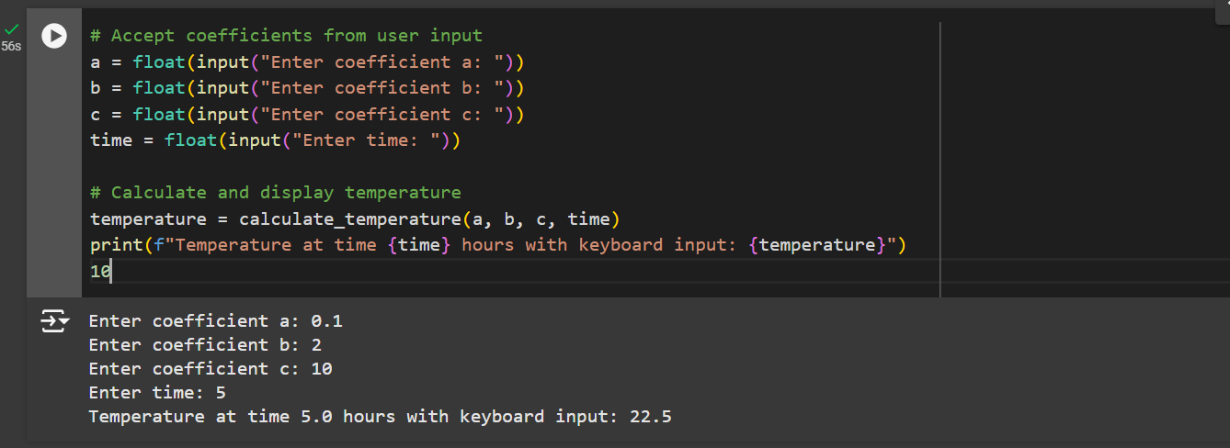

1. Reading Variables from a File:
   * Read coefficients a, b, c, and time from a file.
   * Calculate temperature for each set of inputs read from the file.

Step 1: upload the required files in google drive. So that we can use in code.

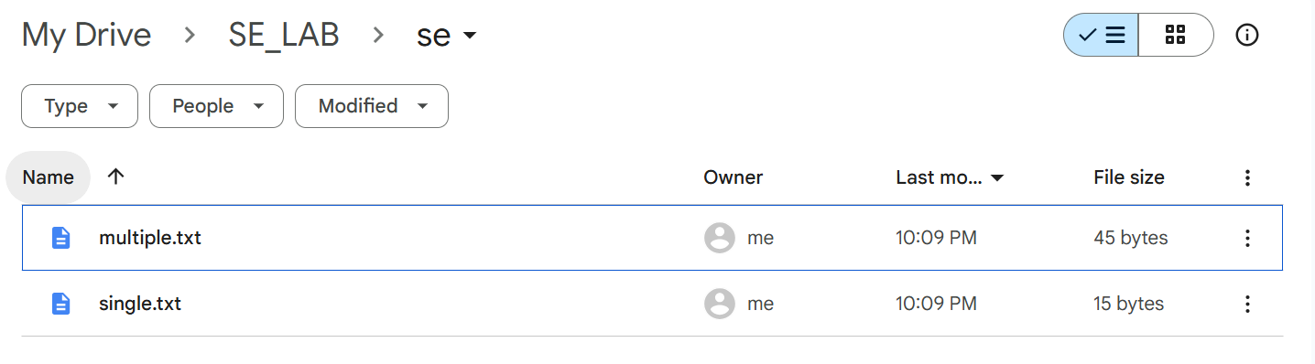

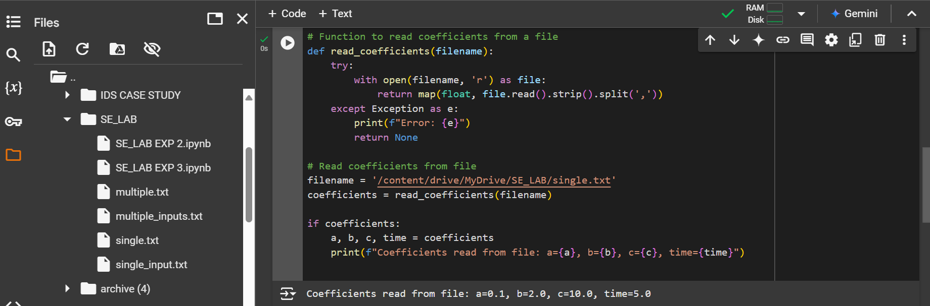

1. Processing a Single Set of Inputs:
   * Read a single set of coefficients from a file.
   * Calculate and display the temperature for this set.

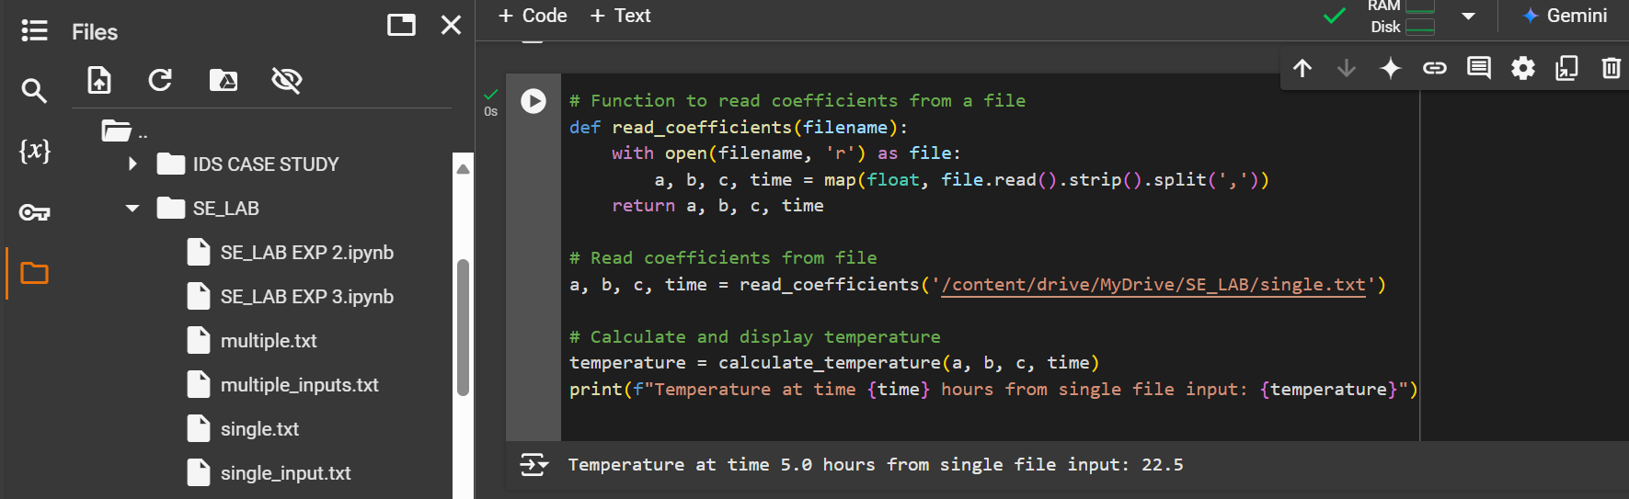

1. Processing Multiple Sets of Inputs:
   * Read multiple sets of coefficients from a file.
   * Calculate and display the temperature for each set.

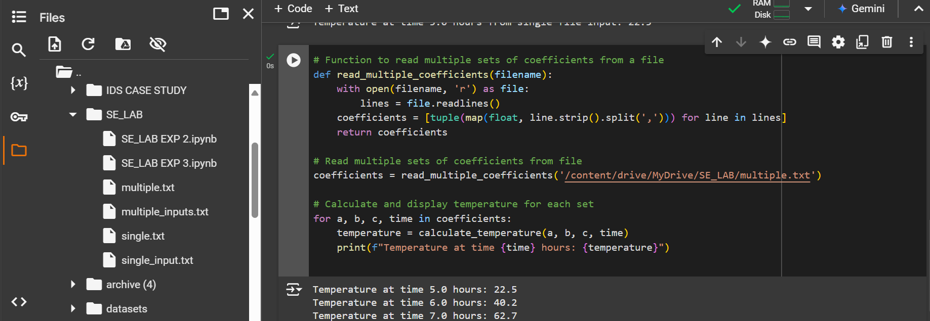

Pushing the project to GitHub.

Step 1: Click on file and select option save a copy in GitHub

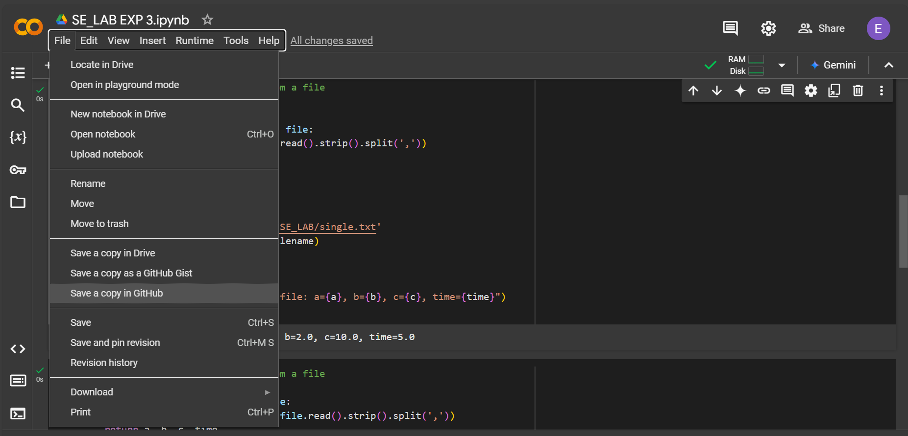

Step 2:Authorize Colaboratory



Step 3: Click on ok for copying to GitHub.

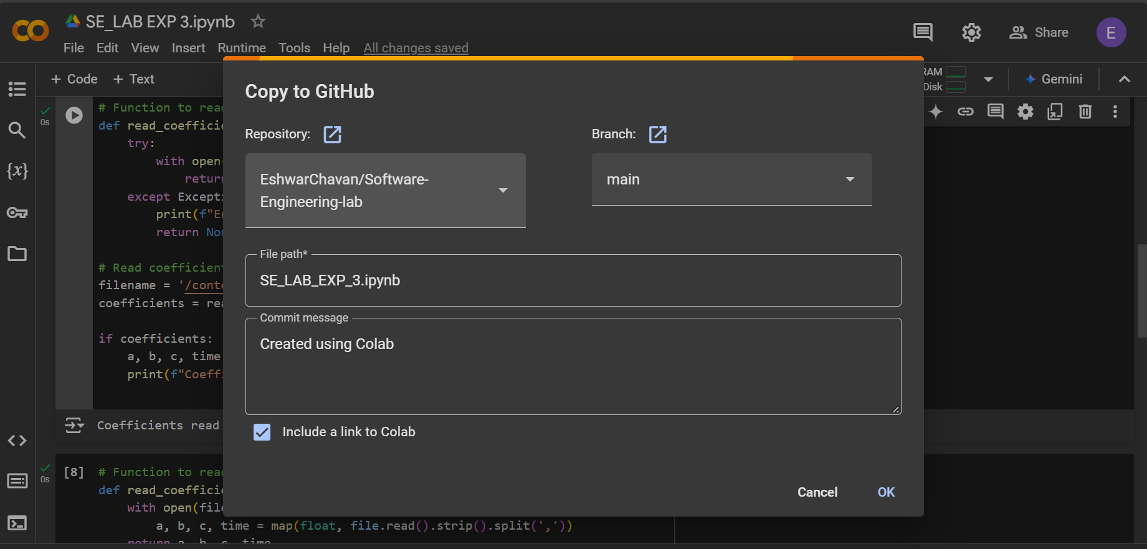

Step 4: Pushed into GitHub

